File Attributes

1. Create a file abc.txt and change the ownership of this file to some other user on your machine,
and also change the group to family.
ANSWER:
Use chown to change ownership of a file
Use chgrp to change the group to family.
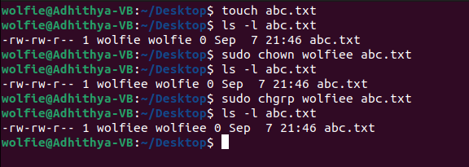

- Create a file exercise.txt and make it executable.
ANSWER:
Use sudo chmod u+x exercise.txt command to make the file executable.

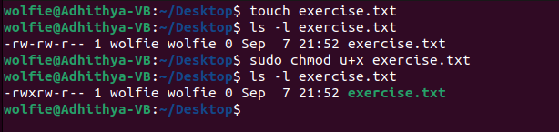

3. Create a file test.txt on your desktop and identify its inode number, also create a softlink for test.txt in your home.
ANSWER:
Use touch filename to create file
Use ls -I test.txt to identify its inode number
Use sudo ln -s test /home/test to create a secondary softlink to test.txt in home

